Council logo

**Oxford City Council Workforce Equalities Report 2021-2023**

Contents

**Introduction** 2

**Definitions** 5

**Headlines** 8

**Oxford City Council Workforce Profile: Trends** 9

**Oxford City Council Workforce Profile: Analysis** 10

**Oxford City Council Management Profile** 18

**Attraction, Recruitment and On-Boarding** 20

**Priority Actions - 2023/2024** 24

**Appendices** 25

Recruitment Activity Data Tables 2020/21 to 2021/23 25

New Starters Data Tables 2020/21 to 2022/23 26

Leavers Data Tables 2020/21 to 2022/23 27

Planned Publication Date January 2024

**Introduction - Message from Chief Executive**

During the last 18 months we have supported our staff and citizens during the cost of living crisis, coping with extra demand for services. We remain committed to improving access and inclusion for our staff and the people we serve. Many in our communities continue to face difficulties in a challenging finanacial environment and so a common theme across all of our work is to tackle inequality and meet the needs of our diverse local communities. It is our strong belief that a diverse workforce that is more representative of our city and a culture of inclusivity and respect is critical to providing the best services to our residents and to bringing out the best in our people.

The 2021 Census data demonstrates that Oxford has become increasingly diverse across its communities. This drives even further our commitment to equality and diversity. To achieve greater equality we will continue to improve our efficiency and effectiveness and performance so that we can deliver the best services for our citizens.

In 2022 we launched our [Equality, Diversity and Inclusion Strategy](https://www.oxford.gov.uk/info/20356/equality_diversity_and_inclusion_strategy), developed using the Local Government Association Equalities Framework, which outlines four areas of focus for equality, diversity and inclusion (EDI).

* Understanding and Working with our Communities
* Leadership and Organisational Commitment
* Responsive Services and Customer Care
* Diverse and Engaged Workforce

Our work during the last year our work has included:

* Implementing improved technology for our staff to improve efficiency and the effectiveness of hybrid working
* Leadership development to build inclusive management practices and support staff to deliver the best outcomes
* Extended the reach of recruitment advertising to encourage more diversity in the people applying for jobs
* Improving career development opportunities to attract, develop and retain talent
* Building a more inclusive culture and sense of belonging through lunch and learn sessions and other EDI focused sessions for staff
* Progress towards our target of 15% for the proportion of the workforce from minority ethnic groups

This report is internally focused on the City Council as an employer, providing a picture of our workforce profile, data trend analysis for a three year period (1 April 2020 to 31 March 2023) for some of the key protected characteristics under the Equality Act, comparative population data and a breakdown of the City Council’s staffing for key equalities reporting areas. We have also provided data in relation to key people processes such as attraction of candidates for jobs, recruitment, on-boarding and leavers.

Not every employee chooses to share their personal data so reporting is based on that data that has been reported. We continue to work with staff to raise awareness of how we use this data, encouraging them to disclose personal data to improve our insight and help us monitor and track our progress.

**Caroline Green**

**Chief Executive**

**About the data**

**Sources of Data**

* The demographic data from the 2021 Census is now available and has been used in this report.
* The Council is analysing data collected from applicants and employees over a rolling three year period to enable greater insight into trends and to confirm the relevance of the current equality action plan and identify any new approaches.

**Who the report includes**

* The report includes all directly employed Council staff, including OX Place. Agency staff and contractors are not included, nor are Oxford Direct Services (ODS). ODS is a wholly owned company, a separate entity from Oxford City Council and not a public body. Therefore the Public Sector Equality Duty (PSED) to report on equalities information does not apply to ODS.

**Provision of equality data**

* The Council asks job applicants and employees to provide data on certain characteristics for statistical monitoring purposes. They are informed that the data provided will only be used in an anonymised way for these purposes. The data is provided on a voluntary basis using our Human Resources Information Management System (iTrent). Employees can amend or remove their information at any time.
* All employees are required to provide data in relation to sex (as assigned at birth) for HMRC purposes and this is used for monitoring purposes in relation to gender.

**Non-reporting**

* We strongly encourage completion of non-mandatory equality data (all data except sex) and provide assurances in relation to confidentiality and use of the data. However, as provision of the data is entirely voluntary we do not have a full picture for the whole of our workforce and integrity of the data analysis is affected.

**Presentation of data**

* For the majority of information presented in the report, percentages have been used. When information has been broken down further, data has been presented in number format due to the small numbers involved.
* Data is either for the whole years of 1st April 2020 to 31st March 2021, 1st April 2021 to 31st March 2022 and 1st April 2022 to 31st March 2023 or on specific dates as at 31st March in 2021, 2022 and 2023.

# **Definitions**

**Minority Ethnic**

**Groups** People declaring themselves as Asian or Asian British (Indian, Pakistani, Bangladeshi, Chinese, Any other Asian background); Black, Black British, Caribbean or African (Caribbean, African, Any other Black, Black British or Caribbean background); Mixed or multiple ethnic Groups (White and Black Caribbean, White and Black African, White and Asian, Any other mixed or multiple ethnic background); Other ethnic group - Arab, Any other ethnic Group.

**Sex** The UK Government defines sex as the biological aspects of an individual as determined by their anatomy, which is produced by their chromosomes, hormones and their interactions; something that is assigned to an individual at birth and is generally female or male.

For HMRC purposes all staff are recorded as either male or female. Where this report refers to gender in respect of employees it usually categorises according to this.

**Gender** The UK Government defines gender as a social construction relating to behaviours and attributes based on labels of masculinity and femininity: gender identity is a personal, internal perception of oneself and so the gender category someone identifies with may not match the sex they were assigned at birth.

Individuals may see themselves as a man, woman, as having no gender, or as having a non-binary gender – where they identify as somewhere on a spectrum between a man and a woman.

Our job application allows applicants to self-identify as male or female or not declare this information.

**Disability** People who consider themselves to have a disability/long term impairment.

**Sexual Orientation**  Sexual orientation is an enduring pattern of romantic or sexual attraction which may be to the opposite sex or gender, same sex or gender or to both sexes and more than one gender.

**LGB** Lesbian, gay and bisexual (LGB).

**White** People declaring themselves as English, Welsh, Scottish, Northern Irish or British; Gypsy or Irish Traveller; Roma; Any other White background.

**Equality, diversity and inclusion achievements – 2022/2023**

We have undertaken a number of activities to proactively support our employees and to meet the goals we set out in our Equalities Action Plan.

* Our People Strategy continues our ambition to put inclusion and respect at the heart of how we develop policy, practice and the behaviour that influences our culture.
* We have completed an engagement survey to help us to understand what our employees think of us as an employer and their experience of working at the authority. The survey now includes a question around belonging and one to test if we are a flexible employer.
* Our recent apprentice recruitment was successful in recruiting a diverse cohort of younger people to develop skills and experience for a successful future.
* Our specialist recruitment consultant has exended the reach of recruitment advertising to attract a more diverse field of candidates and this includes sharing job opportunities with local communities.
* To build a more inclusive culture and foster a greater feeling of belonging we have delivered eleven lunch and learn sessions attended by 458 employees including topics such as Islamophobia, Holocaust Memorial Day, LGBTQ+, neurodiversity, anxiety at work, South Asian Heritage Month, Black History Month and employee networks.
* We delivered a well-being at work week offering support for physical and mental well-being.
* Our employee networks continue to offer employees the opportunity to discuss the issues that affect them and they support our Equalities Steering Group.
* We have now implemented our new approach to equality impact assessments, offering training and support where needed.
* Delivered EDI training for Members and begun Inclusive Recruitment Training for managers.
* Built links wth local schools to offer work experience opportunities and established a relationship with Oxford Brookes University to offer students internships - with a priority for students from ethnically diverse backgrounds.

**Equality, Diversity and Inclusion in our teams**

**From Ian Brooke, Head of Community Services**

One of the aims of the Thriving Communities Strategy is to foster a sense of belonging - We want everyone in Oxford to feel a sense of local pride, be free to be who they are and to feel like they belong.

There is a clear synergy between internal and external equalities work impacting not just our staff but also the lives of our residents and communities. To that extent, here are some key areas of work that complements the workforce diversity work within the Council:

* The Equality, Diversity, and Inclusion Strategy was shortlisted for a Local Government Chronicle (LGC) award which showcased how we re-designed and embedded inclusion and diversity at every stage of the Council’s Grant Review process. Through this work, we now evaluate each grant more inclusively and have embedded EDI impact as a compulsory grant funding criterion. The LGC award application also showed strong place leadership through the work around the Anti-Racism Charter and demonstrated an innovative approach through our Locality Model.
* Our Locality networks (Locality Managers working with patch-based officers from other teams and partners) have continued to put equalities into action with all our work in communities very much focused through an EDI lens. This includes our cost of living support, food banks and effectively targeting grants such as the Houseful Support Fund where they will have the most impact.
* We have strengthened our commitment to be inclusive and embed a culture of continuous learning by designing and organizing fortnightly locality learning sessions, these sessions have included areas such as Inclusive Communication, neurodiversity, Gender, and Race. These sessions are attended predominantly by council employees with some partner agencies such as the County Council and social landlords attending.
* We are actively supporting our leaders to take informed and inclusive decisions, which has included EDI training sessions for our Cabinet members. We have re-designed our Equality Impact Assessment process to improve the way we address and respond to equality and inclusion in our work and service delivery.

# **Headlines**

**Total Workforce:** The number of people employed by the Council has increased from 754 on the 31st March 2022 to 777 on the 31st March 2023 as more people joined the Council than left. During 2022/23, turnover was lower than in the previous year, at 9.8% on average. There was less recruitment activity, with 98 new starters joining the Council, compared to 142 in the previous year.

**Gender:** Over half of the workforce are women (59.7%), which is above that of the population of Oxford at 48.2%. This year, the proportion of women in senior roles has decreased very slightly by 1% to 49%.

**Ethnicity:** Data indicates a small decrease in the representation of employees from minority ethnic groups in the workplace to 14.2%, a negligible shift down from 14.6%. The current target is 15%. The proportion of minority ethnic candidates applying for jobs has increased to 32%, but the proportion appointed has decreased to 14% from 21% in the previous year. Minority ethnic representation in management roles has more than doubled to 9% (26% of managers have not declared their ethnicity). New Census data puts the economically active population from minority ethnic groups at 27.7%, up by 9%.

**Disability:** 10.4% of workforce has declared a disability, which is relatively stable when compared to the previous two years and compares favourably with the local population at 9.2%. Data suggests the proportion of candidates with a disability applying for and appointed to roles increased marginally last year. Disabled employees are fairly well represented at lower grades but has halved to just 2% of senior roles (grade 11+).

**Age:** The average employee age of 45 is in line with the local population where, at 34% of the total population, the 35-49 age band of Oxford residents is the largest. The largest employee group is the 51-60 age band.

**Sexual Orientation:** 4.0% of the Council workforce identifies as bisexual, lesbian or gay. The previous comparator, which was the Annual Population Survey 2018, suggested that 2.2% of the UK population identifies as bisexual, lesbian or gay. The 2021 Census, however, indicates that 4.2% of economically active residents in Oxford (excluding full time students) indentify as bisexual, lesbian or gay. Currently data we collect during recruitment is limited.

**Religious Belief and Non-belief:** 35.4% of the workforce have declared as Christian compared with 41% in Oxford, with 27.5% atheist/humanist/no belief compared to 40% in Oxford and 29.6% have not provided information. 3.7% of the workforce is ‘other’, 1.9% is Muslim (Oxford 7.2%) and 0.4% Sikh (Oxford 0.4%).

**Staff living within Oxford:** the proportion of staff living in Oxford City is 30.89%, which is a reduction of 2% from the previous year.

**Oxford City Council Workforce Profile: Trends**

|  |  |  |  |
| --- | --- | --- | --- |
| *Category* | **2021** | **2022** | **2023** |
| **Total Workforce** | 703 | 754 | 777 |
| **New Starters** | 60 | 142 | 98 |
| **Leavers** | 64 | 107 | 75 |
| **Average Age** | 45 | 44 | 45 |

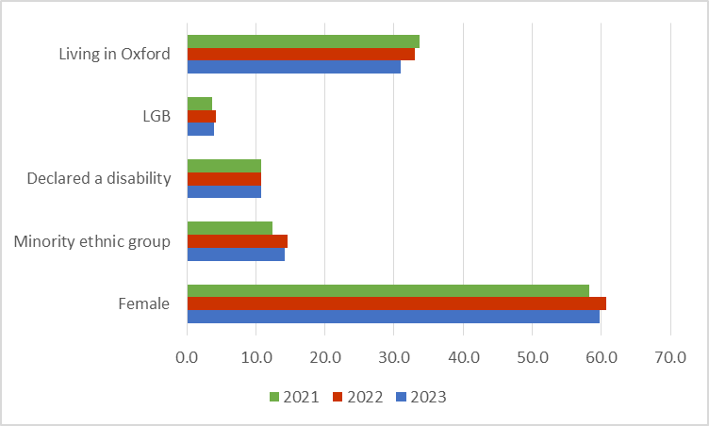

|  |  |  |  |  |  |
| --- | --- | --- | --- | --- | --- |
| **Year** | **Female** | **Minority ethnic group** | **Declared a disability** | **LGB** | **Living in Oxford** |
| 2023 | 59.7 | 14.2 | 10.7 | 4.0 | 30.9 |
| 2022 | 60.7 | 14.6 | 10.7 | 4.2 | 33.0 |
| 2021 | 58.2 | 12.4 | 10.8 | 3.6 | 33.7 |

# **Oxford City Council Workforce Profile: Analysis**

The table below shows the proportion of males and females employed by Oxford City Council compared with economically active females in Oxford

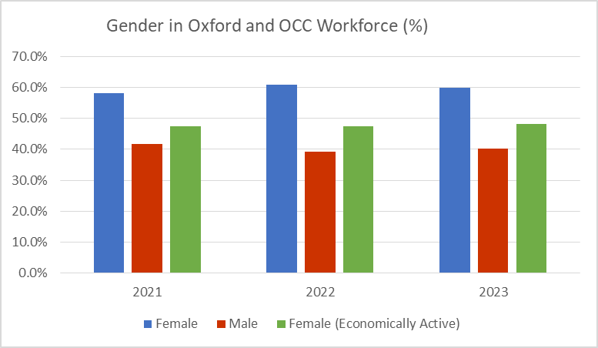

|  |  |  |  |
| --- | --- | --- | --- |
| **Gender** | **2021** | **2022** | **2023** |
| Female | 58.2% | 60.7% | 59.7% |
| Male | 41.8% | 39.3% | 40.3% |
| Female (Economically Active) | 47.5% | 47.5% | 48.2% |

The table below shows the proportion of Oxford City Council employees declaring themselves to be from a minority ethnic group compared with economically active population in Oxford declaring themselves to be from a minority ethnic group

**Graph showing profile of ethnic minorities for the years 2021, 2022 and 2023. Data provided in table below
**

|  |  |  |  |
| --- | --- | --- | --- |
| **Minority Ethnic Group** | **2021** | **2022** | **2023** |
| Council Staff | 10.8% | 14.6% | 14.2% |
| Economically Active | 18.7% | 18.7% | 27.7% |

The table below shows the proportion of Oxford City Council employees declaring a disability compared with the economically active population in Oxford declaring a disability

**Graph showing profile of people declaring a disability for the year 2021, 2022 and 2023. Data provided in table below.
**

|  |  |  |  |
| --- | --- | --- | --- |
| **Disability** | **2021** | **2022** | **2023** |
| Council Staff | 10.8% | 10.7% | 10.4% |
| Economically Active | 6.7% | 6.7% | 9.2% |

The table below shows the proportion of Oxford City Council employees declaring themselves as LGB compared with the economically active population in Oxford.

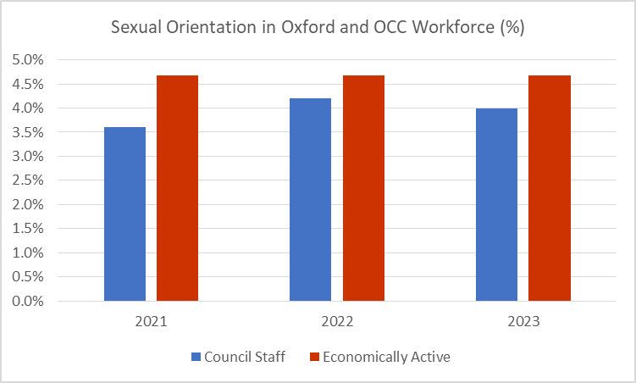

|  |  |  |  |
| --- | --- | --- | --- |
| **LGB** | **2021** | **2022** | **2023** |
| Council Staff | 3.6% | 4.2% | 4.0% |
| Economically Active* | 4.7% | 4.7% | 4.7% |

The table below shows Oxford City Council’s workforce profile by religion/ belief or non-belief

Graph showing profile of religious beliefs and non belief for the year 2021, 2022 and 2023. Data provided in table below.


|  |  |  |  |
| --- | --- | --- | --- |
| **Relgion/Belief & Non Belief** | **2021** | **2022** | **2023** |
| Atheist/Humanist/no beliefs | 28.73% | 27.85% | 27.54% |
| Buddhist | 0.57% | 0.40% | 0.26% |
| Christian | 34.57% | 36.33% | 35.39% |
| Hindu | 1.14% | 1.59% | 1.03% |
| Jewish | 0.14% | 0.27% | 0.13% |
| Muslim | 2.13% | 2.52% | 1.93% |
| Other | 3.56% | 3.98% | 3.73% |
| Sikh | 0.28% | 0.40% | 0.39% |
| Unknown | 28.88% | 26.66% | 29.60% |

The table below shows Oxford City Council’s workforce profile by age band

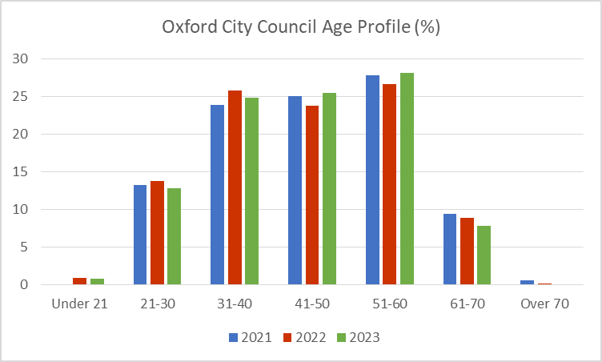

|  |  |  |  |
| --- | --- | --- | --- |
| **Age Band** | **2021** | **2022** | **2023** |
| Under 21 | 0 | 0.93% | 0.77% |
| 21-30 | 13.23% | 13.79% | 12.87% |
| 31-40 | 23.9% | 25.86% | 24.84% |
| 41-50 | 25.04% | 23.74% | 25.48% |
| 51-60 | 27.87% | 26.66% | 28.19% |
| 61-70 | 9.39% | 8.89% | 7.85% |
| Over 70 | 0.57% | 0.13% | 0 |

The table below shows Oxford City Council’s workforce profile by where they live

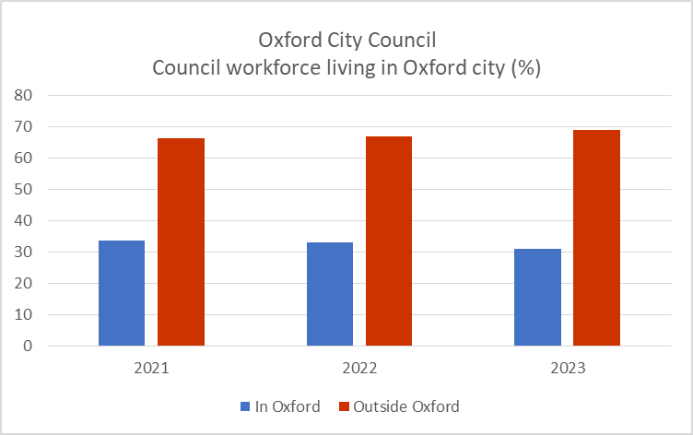

|  |  |  |  |
| --- | --- | --- | --- |
| **Location** | **2021** | **2022** | **2023** |
| In Oxford | 33.71 | 33.02 | 30.89 |
| Outside Oxford | 66.29 | 66.98 | 69.11 |
| Total | 100% | 100% | 100% |

The table below shows the proportion of Oxford City Council employees who have not declared information by each characteristic

**Graph showing profiles of staff not declaring information about protected characteristics for the years 2021, 2022 and 2023. Data provided in table below.
**

|  |  |  |  |
| --- | --- | --- | --- |
| **Characteristic not declared** | **2021** | **2022** | **2023** |
| Ethnicity | 9.67% | 9.28% | 13.51% |
| Disability | 11.24% | 10.90% | 10.88% |
| Sexual Orientation | 27.03% | 24.80% | 26.93% |
| Religious Belief | 28.88% | 21.62% | 29.60% |

**Workforce Profile by Grade and Employment Type**

|  |  |  |  |  |  |  |  |
| --- | --- | --- | --- | --- | --- | --- | --- |
| **Grade** | **Female Full Time** | **Female Part Time** | **Female Total** | **Male Full Time** | **Male Part Time** | **Male Total** | **Total** |
| Apprentice | 5 | 0 | 5 | 4 | 0 | 4 | 9 |
| Grade 03 | 3 | 6 | 9 | 10 | 3 | 13 | 22 |
| Grade 04 | 15 | 12 | 27 | 17 | 4 | 21 | 48 |
| Grade 05 | 59 | 47 | 106 | 39 | 2 | 41 | 147 |
| Grade 06 | 54 | 27 | 81 | 38 | 5 | 43 | 124 |
| Grade 07 | 77 | 31 | 108 | 68 | 3 | 71 | 179 |
| Grade 08 | 32 | 16 | 48 | 51 | 8 | 59 | 107 |
| Grade 09 | 23 | 11 | 34 | 15 | 1 | 16 | 50 |
| Grade 10 | 11 | 7 | 18 | 16 | 0 | 16 | 34 |
| Grade 11 | 11 | 3 | 14 | 13 | 1 | 14 | 28 |
| Service Manager | 1 | 0 | 1 | 1 | 0 | 1 | 2 |
| Business Lead | 4 | 2 | 6 | 5 | 0 | 5 | 11 |
| Service Head | 5 | 0 | 5 | 6 | 0 | 6 | 11 |
| Director | 1 | 0 | 1 | 3 | 0 | 3 | 4 |
| Chief Executive | 1 | 0 | 1 | 0 | 0 | 0 | 1 |
| **Totals** | **302** | **162** | **464** | **286** | **27** | **313** | **777** |

**Graph showing analysis of females and males by full and part time employment within grades. Data provided in table above
**

Workforce Profile Summary

* The total workforce number has increased since March 2022 from 754 to 777. The proportion of women employed by Oxford City Council is 59.7% and compares favourably with Oxford demographic data of 48.2%.
* The number who have not declared their ethnicity has increased from 9.28% in 2022 to 13.51% in 2023. This needs to be addressed to help provide a more comprehensive and accurate picture of our workforce.
* The proportion of the workforce who have not declared their sexual orientation, ethnic group and religion/ belief or non-belief have all significantly increased since last year. The proportion of those not declaring whether they have a disability was static. This is a reversal of the trend in the previous year when the numbers not declaring information reduced. This impacts the integrity of the data.
* Minority ethnic groups represented 14.2% of the Council’s workforce at 31st March 2023, a marginal decrease from last year. This exceeds the Council’s target of 13.5% by 31 March 2022. The new target for 2023 is 15%, a small increase. However, based on the 2021 Census, the economically active minority ethnic population of Oxford is 27.7%. This is an increase of 9% since the 2011 Census.
* The proportion of economically active residents in Oxford who considered themselves to have a disability in the 2021 Census was 9.2%. The proportion of staff who consider themselves to have a disability remained steady every year at around 10.8% and is greater than the proportion of economically active individuals in Oxford.
* The average age of the workforce is 45. Other than the under 21 age band there is very little change year on year. The changes to the under 21 age band are reflective of apprentice recruitment campaigns. 75% of the Council’s workforce is fairly evenly split between the three decade groups within the 30 to 60 age range. The population of Oxford was markedly younger according to previous data but the largest group is now the 35 to 49 years group.
* The number of staff who identify as lesbian, gay or bisexual has marginally decreased from 4.2% to 4.0%. The proportion of economically active residents in Oxford who identified as lesbian, gay or bisexual in the 2021 Census was 4.7%. The number of people not declaring this information has increased from 24.8% in 2022 to 26.93% in 2023.
* The proportion of employees who consider themselves to be atheist or have no religion has remained relatively stable, currently at around 27.5%, which compares to 40% of the population in Oxford. The number of staff who consider themselves to be Christian has decreased marginally to 35.4%. The number not declaring their religion is relatively high at 29.6%, compared to the Oxford population where 7.3% of religious belief is unknown. The proportion of staff not declaring this information has increased from 21.62% in 2022 to 29.6% in 2023.
* The proportion of staff living outside the city centre has risen from 66.98% in 2022 to 69.11% in 2023. The increase of 2% in the last year is likely to reflect the new working arrangement enabling more home working and therefore being able to attract staff from a wider geographical area. This is also likely to be related to the fact that Oxford remains the most expensive place to live in the UK outside London. Also, the City Council is able to attract talent from across the country due to its ambitious agenda and reputation, flexible and remote working arrangements and employee benefits.
* There is a fairly good representation of women in roles up to Grade 9. There are significantly more women than men in grades 5 to 7, which account for 64% of all females.
* Almost quarter of the Council’s workforce is part time – the majority working part time are women with only 27 men working less than full time hours. There is a fairly even spread of part time workers across all grades up to grade 10, but fewer in management roles above grade 11. Full time staff are able to work flexibly and this is generally appreciated as a good benefit.

# **Oxford City Council Management Profile**

For the purposes of this report, senior managers are defined as those in the following positions:

* Chief Executive
* Executive Directors
* Heads of Service
* Business Leads
* Service Managers
* Grade 11

Graph showing management profile by characteristics for the years 2021, 2022 and 2023. Data provided in table below.


|  |  |  |  |
| --- | --- | --- | --- |
| **Characteristic** | **2021** | **2022** | **2023** |
| Female | 41% | 50% | 49% |
| Minority Ethnic Group | 6% | 4% | 9% |
| Disabled | 6% | 4% | 2% |

|  |  |  |  |
| --- | --- | --- | --- |
| **Information not declared** | **2021** | **2022** | **2023** |
| Ethnicity | 29% | 22% | 26% |
| Disability | 33% | 26% | 32% |

Graph showing management representation by working pattern for the years 2021,2021 and 2023. Data provided in table below.


|  |  |  |  |
| --- | --- | --- | --- |
| **Working Pattern** | **2021** | **2022** | **2023** |
| Full Time Female | 35% | 44% | 40% |
| Part Time Female | 6% | 6% | 9% |
| Full Time Male | 55% | 50% | 49% |
| Part Time Male | 4% | 0% | 2% |

**Summary of Management Profile**

* Since the last report, the number of women in management roles has decreased by 1%, but is still 8% higher than 2 years ago. They now represent half (49%) of the management workforce, although this is not reflective of the total representation of women in the Council, which is 59.7%.
* The proportion of the managers from minority ethnic groups has doubled from 4% to 9%. It must, however, be noted that a large and increasing proportion of employees (from 22% to 26%) have not declared their ethnicity so we do not have an accurate picture.
* 2% of people in management roles have declared they have a disability which is a decrease from 4% for the previous period. Again, the number of people who have not to declared this information is significant at 32%.
* The proportion of managers who are in part-time roles is low, at only 11% . However, it should be noted that this data does not include all flexible working patterns.

# **Attraction, Recruitment and On-Boarding**

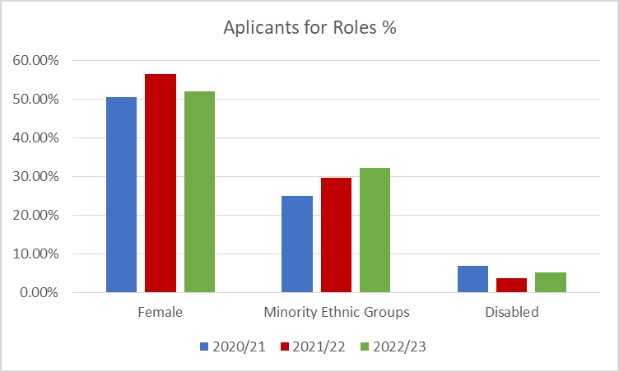

| **Characteristic** | **2020/21** | **2021/22** | **2022/23** |
| --- | --- | --- | --- |
| Female | 50.57% | 56.48% | 52.01% |
| Minority Ethnic Groups | 25.05% | 29.57% | 32.21% |
| Disabled | 6.79% | 3.66% | 5.23% |

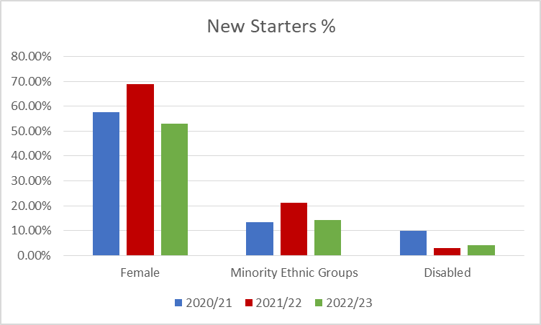

| **Characteristic** | **2020/21** | **2021/22** | **2022/23** |
| --- | --- | --- | --- |
| Female | 57.67% | 69.01% | 53.06% |
| Minority Ethnic Groups | 13.33% | 21.13% | 14.29% |
| Disabled | 10.00% | 2.82% | 4.08% |

**Summary of Attraction, Recruitment and On-boarding**

* Over the reporting period, the total number of new starters joining Oxford City Council has fluctuated, dropping in 2020/21 to 60 and then increasing to 142 in 2021/22, its highest level in recent years, and decreasing to 98 in 2022/23. The reduction in 2020/21 can be attributed to the challenging circumstances facing the country during the pandemic and the increased recruitment in 2021/22 due to an increase in the size of the workforce overall and an increase in employee turnover. At 98, the number of new starters in 2022/23 is representative of a more normal level of turnover and may be the start of some stabilisation following the pandemic.
* The data shows that the proportion of female applicants has decreased by 5% to 51% and the proportion of females being appointed decreased by 7% to 53%.
* For data captured on our system, the number of applicants increased marginally even though number of opportunities reduced, indicating that more people were applying for each role.
* There was an increase in applicants from minority ethnic groups of 2% (up to 32%), but only 14% of new starters were from minority ethnic groups, which is a reduction of 7%.
* There was a 1% increase in both applications and new starters declaring a disability at 5% and 4% respectively, but this is significantly lower than in 2020/21 which when 7% of applicants and 10% of new starters declared a disability.
* It is difficult to draw firm conclusions in relation to the two points above as recruitment activity is only captured for applications though the Council’s Human Resource Management Information System (HRMIS). A number of new starters will not have come through this route. The number of applicants (via the HRMIS) that do not declare their ethnicity or disability status each year is fairly stable at approximately 9% and 14% respectively. When looking at new starters, the number of people not declaring ethnicity was 43% in 2020/21, dropping to 21% in 2021/22 and rising again in 2022/23 to 44%. The situation is similar for those declaring a disability with the respective numbers for each year being 43%, 24% and 50%.
* The number of leavers reduced significantly last year to 75 from 107 in the previous year. The profile of leavers for females and those declaring a disability was broadly comparable with the overall workforce profile. The number of leavers from ethnic minority groups was higher at 16% compared with 14.2% of the workforce declaring to be from a minority ethnic group.

**Leavers**

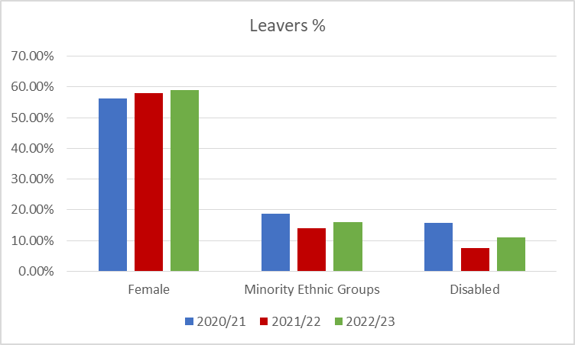

|  |  |  |  |
| --- | --- | --- | --- |
| **Characteristic** | **2020/21** | **2021/22** | **2022/23** |
| Female | 56.25% | 57.90% | 59% |
| Minority Ethnic Groups | 18.75% | 14% | 16% |
| Disabled | 15.63% | 7.50% | 11% |

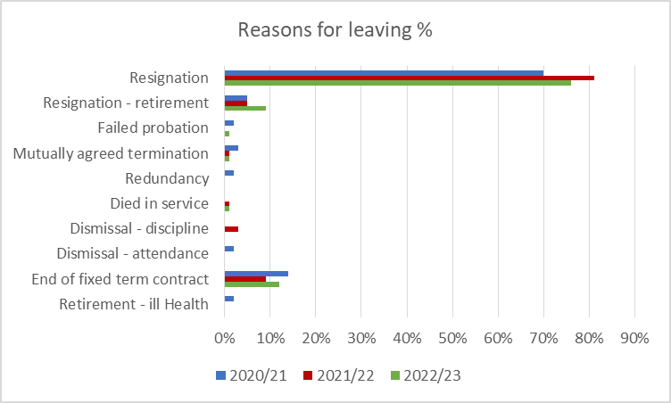

|  |  |  |  |
| --- | --- | --- | --- |
| **Leaving Reason** | **2020/21** | **2021/22** | **2022/23** |
| Resignation | 70% | 81% | 76% |
| Resignation - retirement | 5% | 5% | 9% |
| Failed probation | 2% | 0% | 1% |
| Mutually agreed termination | 3% | 1% | 1% |
| Redundancy | 2% | 0% | 0% |
| Died in service | 0% | 1% | 1% |
| Dismissal - discipline | 0% | 3% | 0% |
| Dismissal - attendance | 2% | 0% | 0% |
| End of fixed term contract | 14% | 9% | 12% |
| Retirement - ill Health | 2% | 0 | 0 |

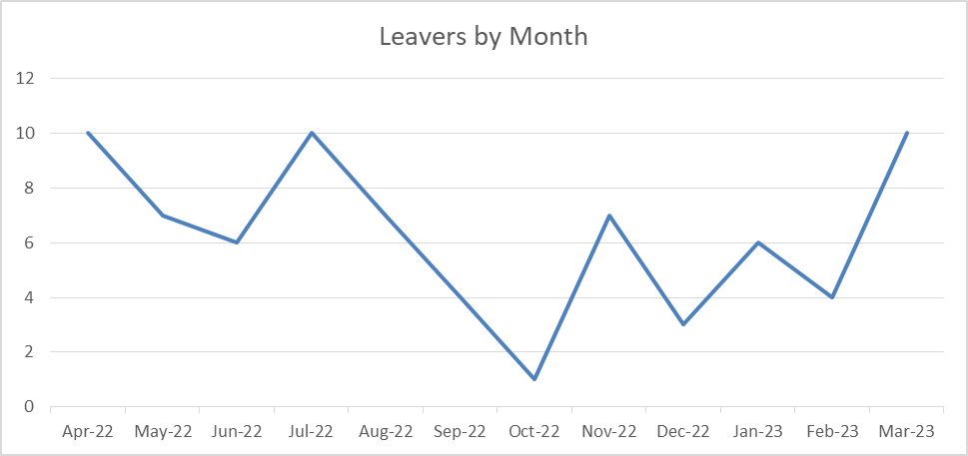

|  |  |  |  |  |  |  |  |  |  |  |  |  |
| --- | --- | --- | --- | --- | --- | --- | --- | --- | --- | --- | --- | --- |
| **Month** | **Apr-22** | **May-22** | **Jun-22** | **Jul-22** | **Aug-22** | **Sep-22** | **Oct-22** | **Nov-22** | **Dec-22** | **Jan-23** | **Feb-23** | **Mar-23** |
| Number | 10 | 7 | 6 | 10 | 7 | 4 | 1 | 7 | 3 | 6 | 4 | 10 |

**Leavers Summary**

* The average turnover as at the 31st March 2023 was 9.8%.
* Overall the proportion of female leavers has increased over the reporting period (2020-2023). The proportions of minority ethnic and disabled leavers have fluctuated over the period as has the number of people who have not declared information. It is therefore difficult to draw any conclusion in relation to trends. The data for leavers in 2022/23 indicates that the proportion of leavers is broadly representative of the current workforce for females and those declaring a disability, however the proportion of leavers from minority ethnic groups is higher than current representation in the workforce.
* The number of leavers who have voluntarily resigned has increased across the reporting period from 75% in 2021/22 to 81% in 2021/22 and 85% last year. Notably the number of people resigning to retire almost doubled last year from 5% to 9%.
* The top 3 reasons for leaving are Voluntary Resignation, End of Fixed Term Contract and Volunatary Resignation to Retire. This has remained consistent across the reporting period. .

# **Priority Actions - 2023/2024**

Continue work to improve diversity of our workforce by building inclusive recruitment practices to improve the diversity of candidates and recruits and offering development for aspiring managers**.** This will include:

* Guidance and inclusive recruitment training for managers
* Introducing more inclusive recruitment practices including a requirement for more diverse panels for senior roles
* Strengthening contacts with schools, colleges and local community networks
* Offering work experience for students in our targeted schools
* Positive action leadership development programme for a cohort of under-represented groups at senior levels
* Work with Activate Learning to develop skills in local communities and develop more apprenticeship opportunities
* Working in and with communities to improve the reach of recruitment

Continue to build inclusive leadership practices and culture. This will include:

* EDI training for managers and employees
* Ongoing lunch and learn sessions to raises awareness and build inclusion and a sense of belonging for all groups
* Regular communications on best practice and ideas to inspire change
* Building the influence and strength of our Equalities Steering Group to better integrate Equality, Diversity, Inclusion and Belonging with policy, service design and operational delivery
* Design a structured approach to staff networks to increase the number and establish a clear purpose and opportunities to influence
* Establish a new REACH staff network for Race, Ethnicity and Cultural Heritage

Improve the understanding of our workforce and individual employee experiences. This will include:

* Improved collection of personal data in people processes
* Reaching out to individuals to learn about their experience of the organisation
* Ongoing staff surveys and evaluation of results
* Developing a data dashboard to better measure and share the workforce profile and the effectiveness of recruitment processes
* Working closely with Union colleagues and their equality and diversity leads
* Continue to build inclusive leadership practices and culture
* Improve the understanding of our workforce and individual employee experiences.

# **Appendices**

## Recruitment Activity Data Tables 2020/21 to 2021/23

Job applications in 2020/21

|  |  |  |
| --- | --- | --- |
| **Characteristic** | **Number** | **Percentage** |
| Female | 529 | 51% |
| Male | 449 | 43% |
| Sex Not Declared | 68 | 6% |
| Minority Ethnic Groups | 262 | 25% |
| White | 686 | 66% |
| Ethnicity Not Declared | 98 | 9% |
| Not Disabled | 839 | 80% |
| Disabled | 71 | 7% |
| Disability Not Declared | 136 | 13% |
| **Total Applications** | **1046** | **100%** |

Job applications in 2021/22

|  |  |  |
| --- | --- | --- |
| **Characteristic** | **Number** | **Percentage** |
| Female | 571 | 56% |
| Male | 384 | 38% |
| Sex Not Declared | 56 | 6% |
| Minority Ethnic Groups | 299 | 30% |
| White | 624 | 61% |
| Ethnicity Not Declared | 88 | 9% |
| Not Disabled | 831 | 82% |
| Disabled | 37 | 4% |
| Disability Not Declared | 143 | 14% |
| **Total Applications** | **1011** | **100%** |
|  |  |  |

Job applications 2022/23

| **Characteristic** | **Number** | **Percentage** |
| --- | --- | --- |
| Female | 557 | 52% |
| Male | 440 | 41% |
| Sex Not Declared | 74 | 7% |
| Minority Ethnic Groups | 345 | 32% |
| White | 625 | 59% |
| Ethnicity Not Declared | 101 | 9% |
| Not Disabled | 849 | 79% |
| Disabled | 56 | 5% |
| Disability Not Declared | 166 | 16% |
| **Total Applications** | **1071** | **100%** |

## New Starters Data Tables 2020/21 to 2022/23

Starters in 2020/21

|  |  |  |
| --- | --- | --- |
| **Characteristic** | **Number** | **Percentage** |
| Female | 34 | 57% |
| Male | 26 | 43% |
| Minority Ethnic Groups | 8 | 14% |
| White | 26 | 43% |
| Ethnicity Not Declared | 26 | 43% |
| Not Disabled | 28 | 47% |
| Disabled | 6 | 10% |
| Disability Not Declared | 26 | 43% |
| **Total Starters** | **60** | **100%** |

Starters in 2021/22

|  |  |  |
| --- | --- | --- |
| **Characteristic** | **Number** | **Percentage** |
| Female | 98 | 69% |
| Male | 44 | 31% |
| Minority Ethnic Groups | 30 | 21% |
| White | 82 | 58% |
| Ethnicity Not Declared | 30 | 21% |
| Not Disabled | 104 | 73% |
| Disabled | 4 | 3% |
| Disability Not Declared | 34 | 24% |
| **Total Starters** | **142** | **100%** |

Starters in 2022/23

|  |  |  |
| --- | --- | --- |
| **Characteristic** | **Number** | **Percentage** |
| Female | 52 | 53% |
| Male | 46 | 47% |
| Minority Ethnic Groups | 14 | 14% |
| White | 41 | 42% |
| Ethnicity Not Declared | 43 | 44% |
| Not Disabled | 45 | 46% |
| Disabled | 4 | 4% |
| Disability Not Declared | 49 | 50% |
| **Total Starters** | **98** | **100%** |

## Leavers Data Tables 2020/21 to 2022/23

Leavers in 2020/21

|  |  |  |
| --- | --- | --- |
| **Characteristic** | **Number** | **Percentage** |
| Female | 36 | 56% |
| Male | 28 | 44% |
| Minority Ethnic Groups | 12 | 19% |
| White | 42 | 65% |
| Ethnicity Not Declared | 10 | 16% |
| Not Disabled | 39 | 61% |
| Disabled | 10 | 16% |
| Disability Not Declared | 15 | 23% |
| **Total Leavers** | **64** | **100%** |

Leavers in 2021/22

|  |  |  |
| --- | --- | --- |
| **Characteristic** | **Number** | **Percentage** |
| Female | 80 | 58% |
| Male | 45 | 42% |
| Minority Ethnic Groups | 15 | 14% |
| White | 68 | 64% |
| Ethnicity Not Declared | 24 | 22% |
| Not Disabled | 72 | 67% |
| Disabled | 8 | 8% |
| Disability Not Declared | 27 | 25% |
| **Total Leavers** | **107** | **100%** |
|  |  |  |

Leavers in 2022/23

|  |  |  |
| --- | --- | --- |
| **Characteristic** | **Number** | **Percentage** |
| Female | 44 | 59% |
| Male | 31 | 41% |
| Minority Ethnic Groups | 12 | 16% |
| White | 55 | 73% |
| Ethnicity Not Declared | 8 | 11% |
| Not Disabled | 55 | 73% |
| Disabled | 8 | 11% |
| Disability Not Declared | 12 | 16% |
| **Total Leavers** | **75** | **100%** |